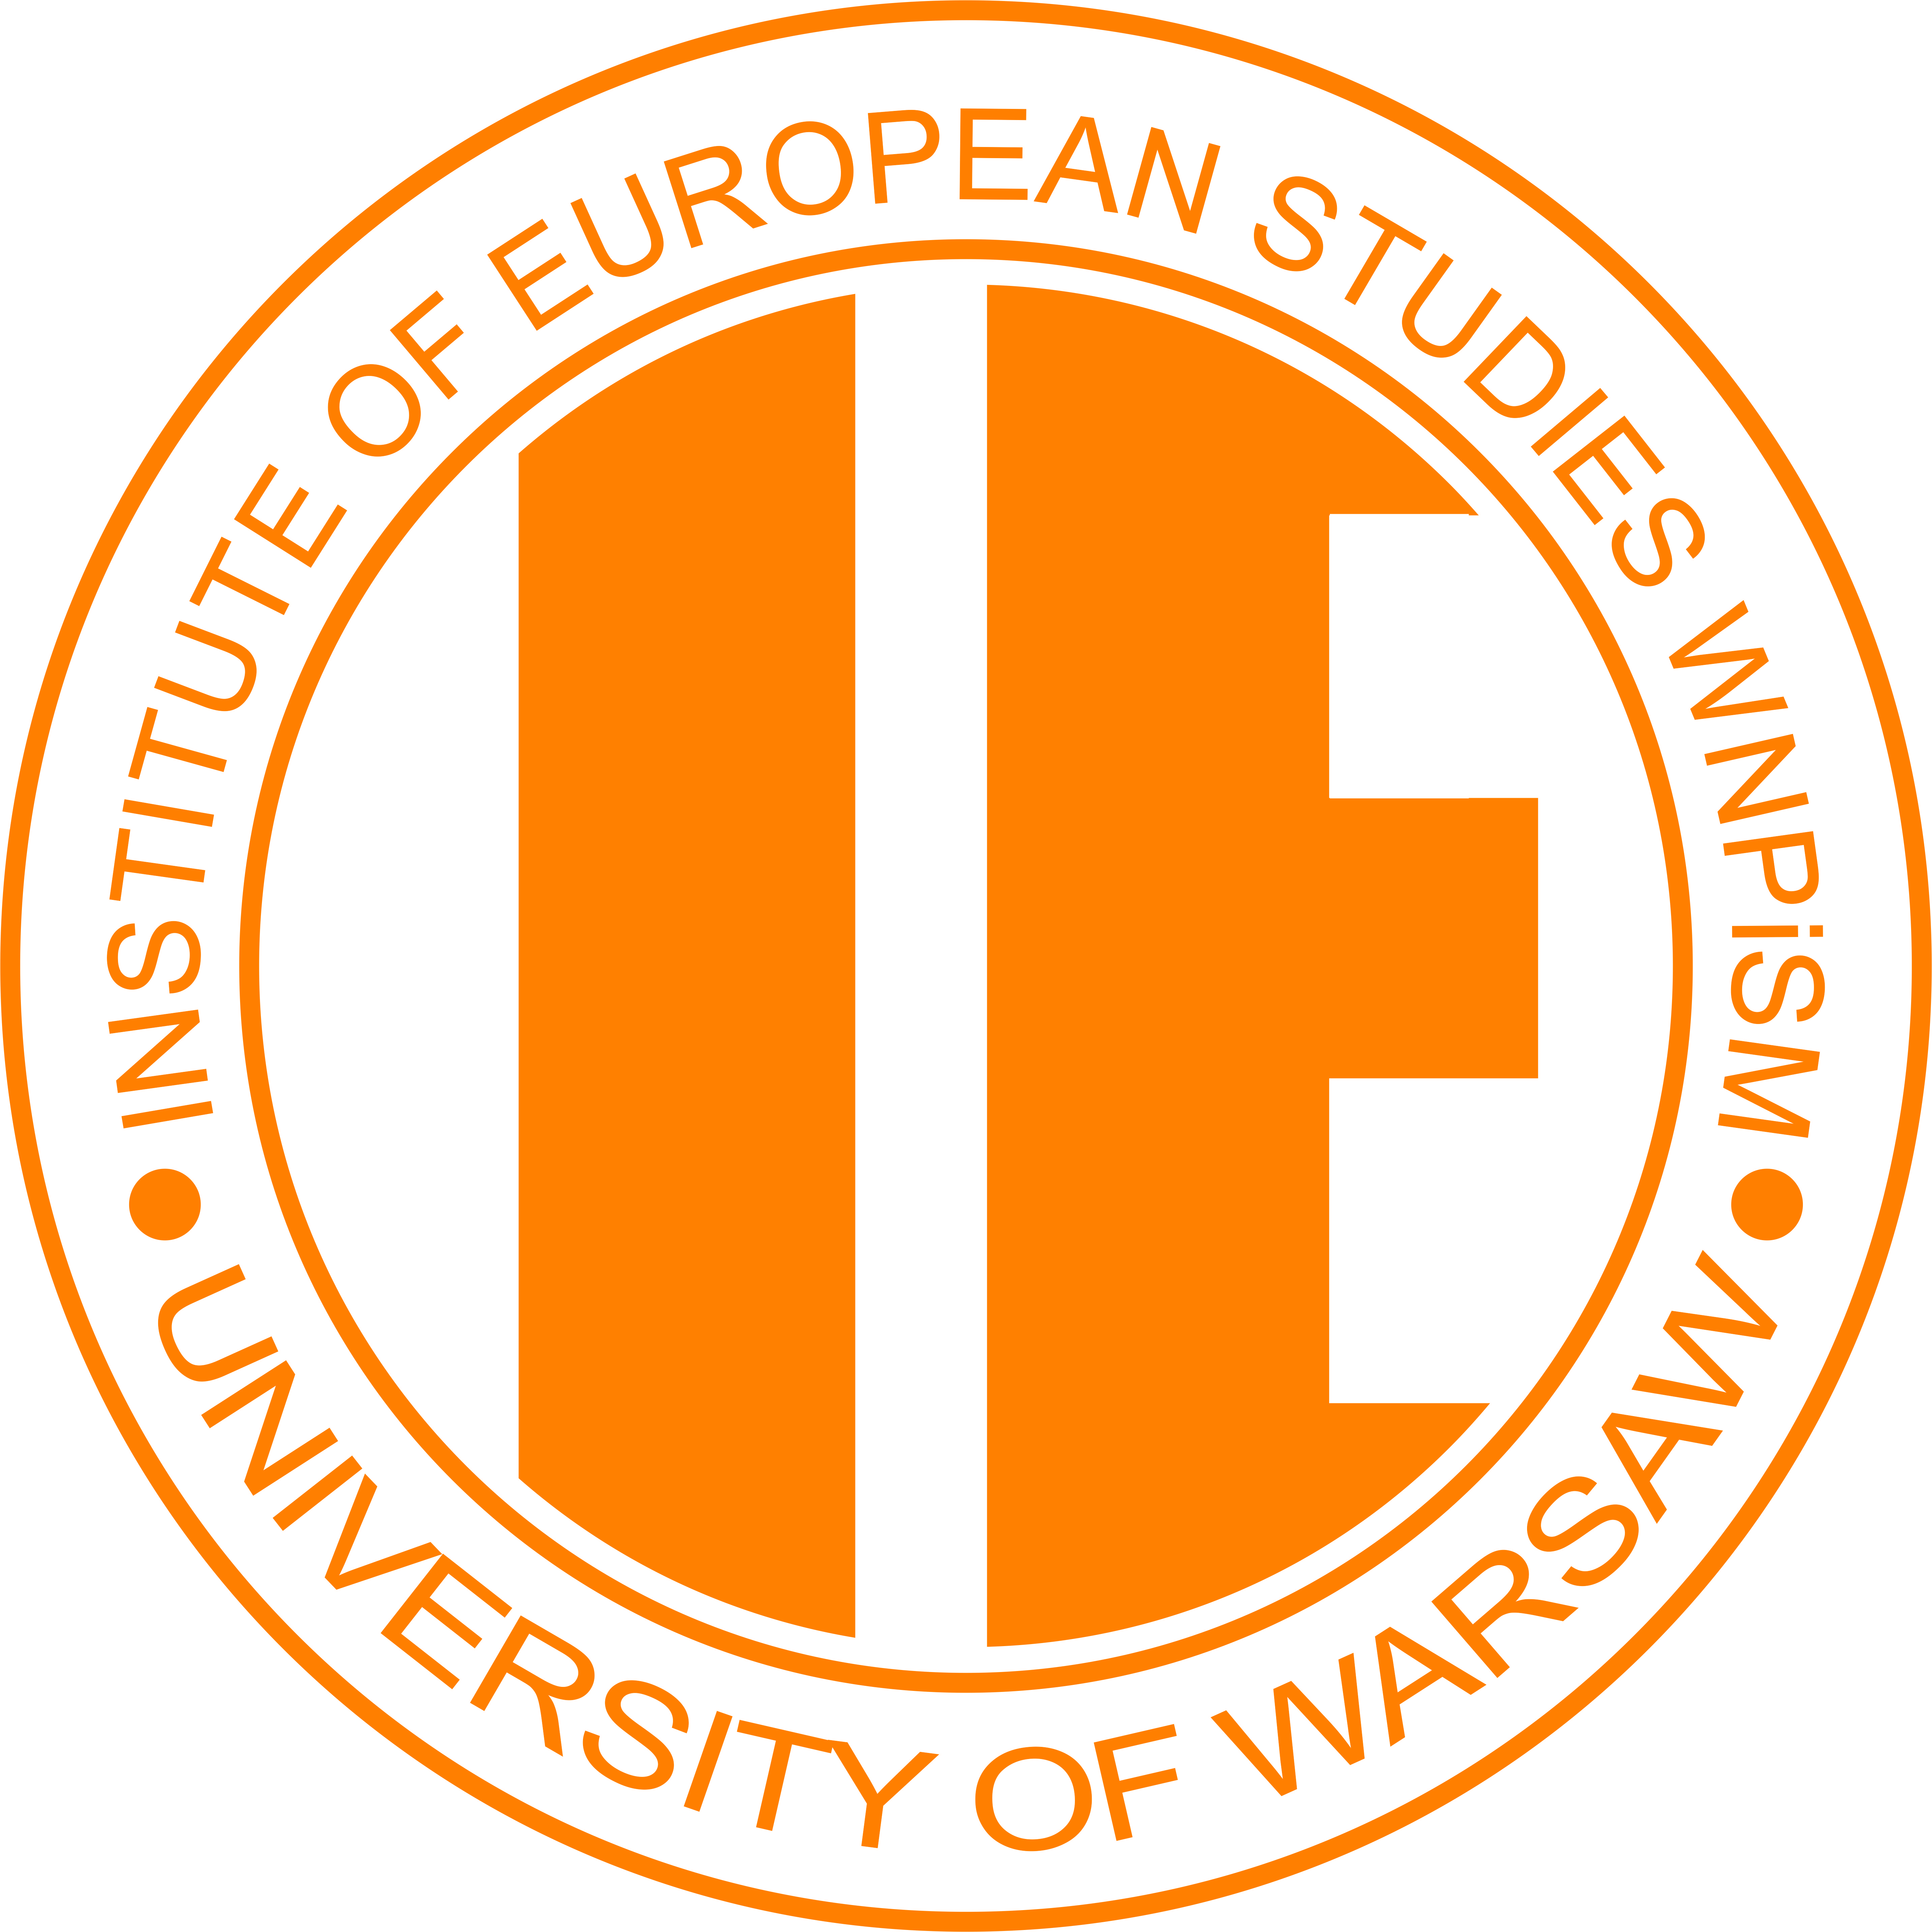
University of Warsaw
Faculty of Political Science and International Studies
Institute of European Studies

CONFERENCE REGISTRATION FORM
Global Consequences of One Belt, One Road
7 June 2017

Participant’s data
Name and surname
Phone number
e-mail address:
Academic title or degree:
Affiliation:

Paper proposal
Title of a paper:
Keywords:
Abstract (1300 - 2000 characters with spaces):
Do you require multimedia projector : | YES | NO

To register submit your filled in registration form by April 9th, 2017 to dknsuw@gmail.com
In the subject of email please include title of the conference and your name.
Abstract selection will be announced before April 30th, 2017.

